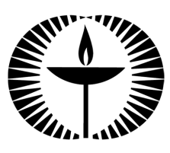
Touchstones Project
Netcards

Courage Netcards with Text

ABC HRJ
Artist HRJ
Basketball HRJ
Brave HRJ

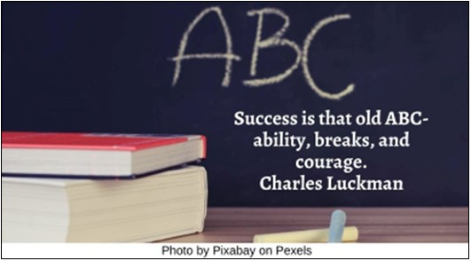

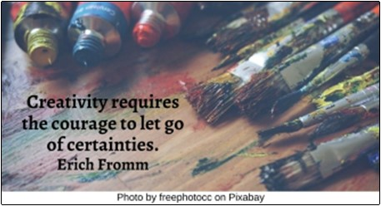

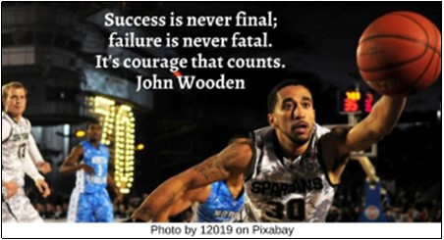

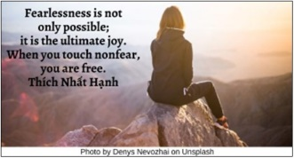

Caution HRJ
Conformity HRJ
Dancer HRJ
Disneyland HRJ

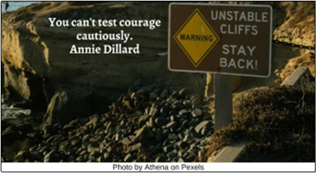

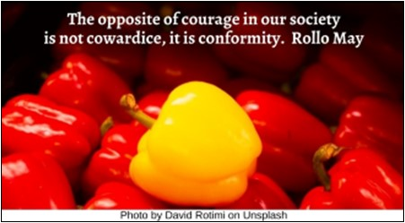

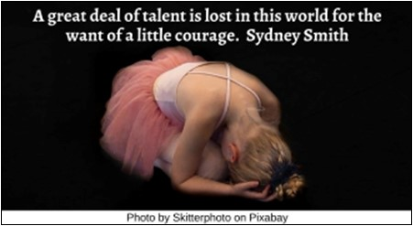

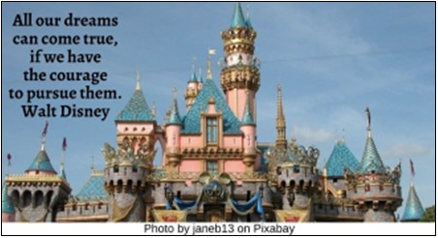

Failure HRJ
Fighter HRJ
Flag of Ukraine HRJ
Flood HRJ

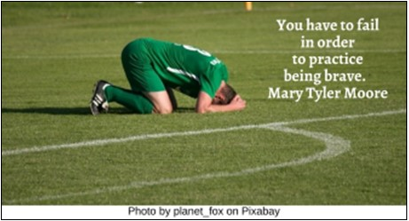

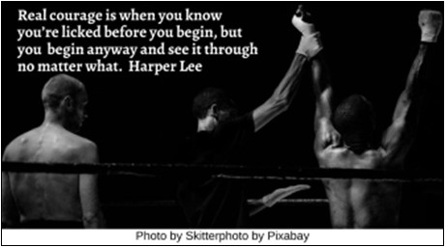

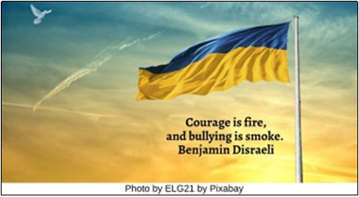

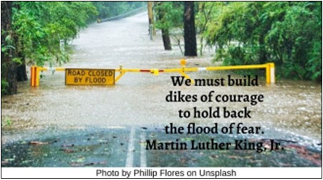

How Far HRJ
Kite HRJ
Meditation HRJ
Mirror HRJ

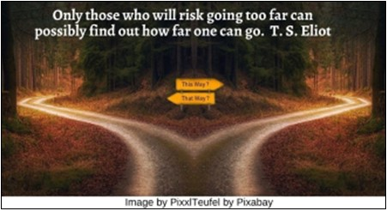

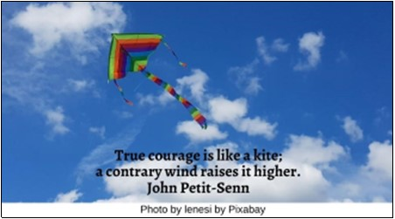

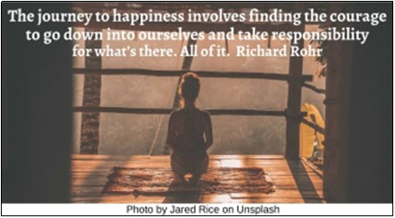

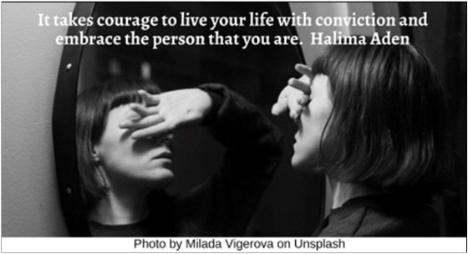

Nelson Mandela HRJ
No HRJ
Ocean HRJ
Oprah Winfrey HRJ

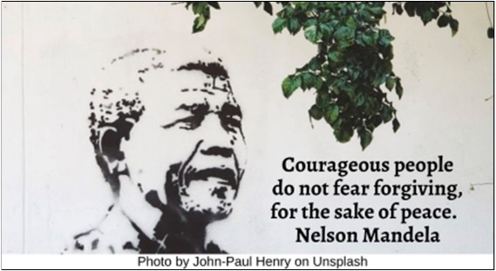

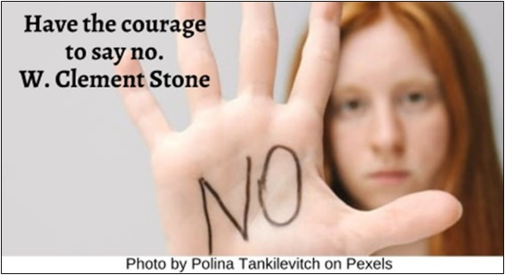

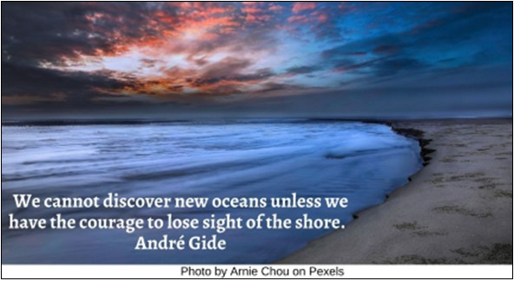

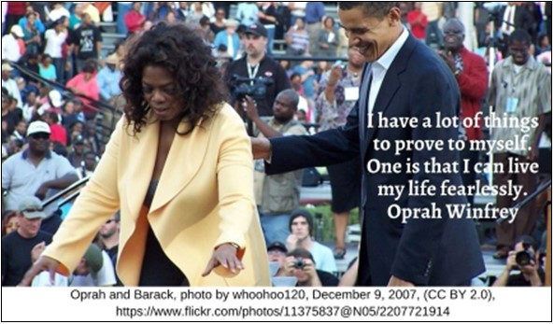

Peace HRJ
Pocket Watch HRJ
Scared Child HRJ
Sorrow HRJ

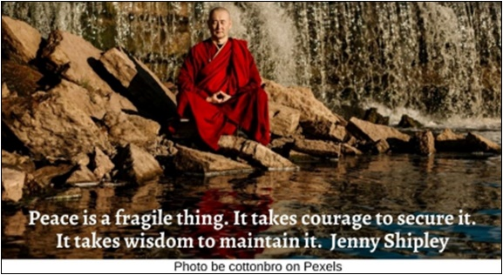

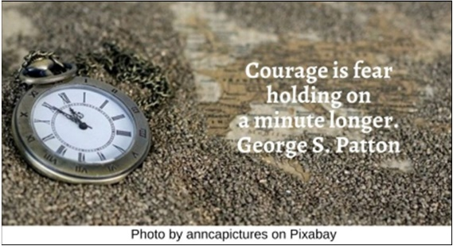

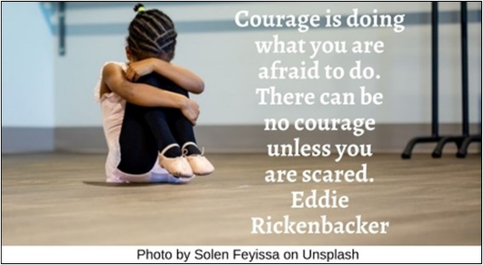

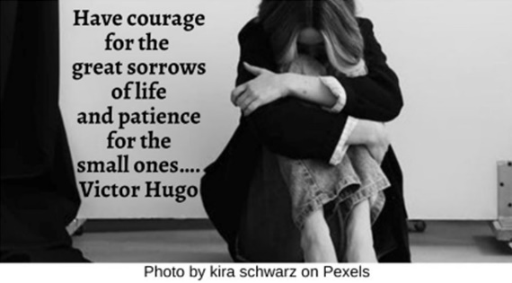

Starry Night HRJ
Teenager HRJ
Ukraine HRJ
Virtue HRJ

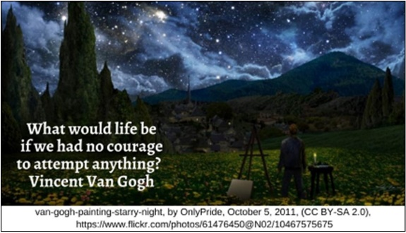

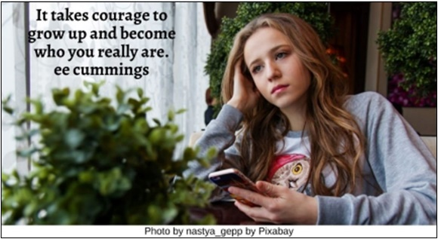

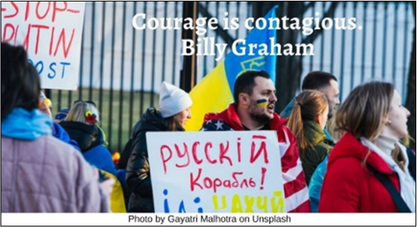

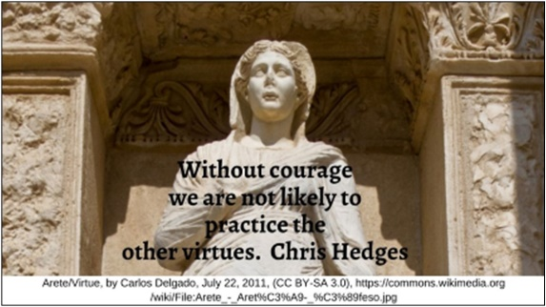

Vote HRJ
War HRJ
Wizard of Oz HRJ

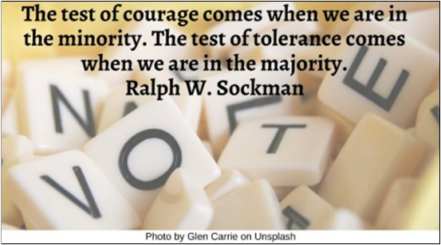

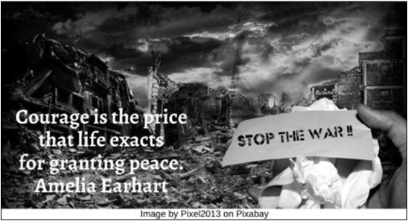

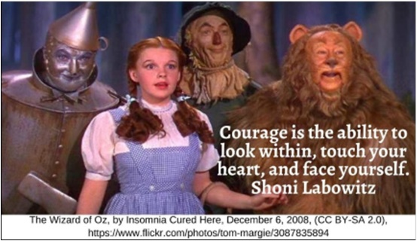

Text of Quotes
ABC HRJ
Success is that old ABC—ability, breaks, and courage. Charles Luckman

Artist HRJ
Creativity requires the courage to let go of certainties. Erich Fromm

Basketball HRJ
Success is never final; failure is never fatal. It’s courage that counts. John Wooden

Brave HRJ
Fearlessness is not only possible; it is the ultimate joy. When you touch nonfear, you are free. Thích Nhất Hạnh

Caution HRJ
You can’t test courage cautiously. Annie Dillard

Conformity HRJ
The opposite of courage in our society is not cowardice, it is conformity. Rollo May

Dancer HRJ
A great deal of talent is lost in this world for the want of a little courage. Sydney Smith

Disneyland HRJ
All our dreams can come true, if we have the courage to pursue them. Walt Disney

Failure HRJ
You have to fail in order to practice being brave. Mary Tyler Moore

Fighter HRJ
Real courage is when you know you’re licked before you begin, but you begin anyway and see it through no matter what. Harper Lee

Flag of Ukraine HRJ
Courage is fire, and bullying is smoke. Benjamin Disraeli

Flood HRJ
We must build dikes of courage to hold back the flood of fear. Martin Luther King, Jr.

How Far HRJ
Only those who will risk going too far can possibly find out how far one can go. T. S. Eliot

Kite HRJ
True courage is like a kite; a contrary wind raises it higher. John Petit-Senn

Meditation HRJ
The journey to happiness involves finding the courage to go down into ourselves and take responsibility for what’s there. All of it. Richard Rohr

Mirror HRJ
It takes courage to live your life with conviction and embrace the person that you are. Halima Aden

Nelson Mandela HRJ
Courageous people do not fear forgiving, for the sake of peace. Nelson Mandela

No HRJ
Have the courage to say no. W. Clement Stone

Ocean HRJ
We cannot discover new oceans unless we have the courage to lose sight of the shore. André Gide

Oprah Winfrey HRJ
I have a lot of things to prove to myself. One is that I can live my life fearlessly. Oprah Winfrey

Peace HRJ
Peace is a fragile thing. It takes courage to secure it. It takes wisdom to maintain it. Jenny Shipley

Pocket Watch HRJ
Courage is fear holding on a minute longer. George S. Patton

Scared Child HRJ
Courage is doing what you are afraid to do. There can be no courage unless you are scared. Eddie Rickenbacker

Sorrow HRJ
Have courage for the great sorrows of life and patience for the small ones…. Victor Hugo

Starry Night HRJ
What would life be if we had no courage to attempt anything? Vincent Van Gogh

Teenager HRJ
It takes courage to grow up and become who you really are. ee cummings

Ukraine HRJ
Courage is contagious. Billy Graham

Virtue HRJ
Without courage we are not likely to practice the other virtues. Chris Hedges

Vote HRJ
The test of courage comes when we are in the minority. The test of tolerance comes when we are in the majority. Ralph W. Sockman

War HRJ
Courage is the price that life exacts for granting peace. Amelia Earhart

Wizard of Oz HRJ
Courage is the ability to look within, touch your heart, and face yourself. Shoni Labowitz

